**Bahria University, Lahore Campus**

Department of Computer Sciences

Lab Journal 07

**(Fall 2023)**

|  |  |  |
| --- | --- | --- |
| Course: | **Digital Communication Network Lab** | Date: 02-11-2023 |
| Course Code: | CSL-320 | Max Marks: 20 |
| Faculty’s Name: | Dawood Akram | Lab Engineer: Muhammad Umar Nasir |

Name: _____________________________ Enroll No: _______________________

**Objective(s):**

In this lab, students will configure OSPF routing protocol.

**Tool(s) used:**

CISCO packet tracer

## Open Shortest Path First (OSPF) Basics

Open Shortest Path First (OSPF) is an open standard link state routing protocol that’s been implemented by a wide variety of network vendors, including Cisco. And it’s open standard characteristic that’s the key to OSPF’s flexibility and popularity.

OSPF works by using the Dijkstra Algorithm to initially construct a shortest path tree and follows that by populating the routing table with the resulting best paths. It is quickly convergent. Another two great advantages OSPF offers are that it supports multiple, equal cost routes to the same destination, also supports both IP and IPv6 routed protocols. OSPF’s best features are:

* Allows the creation of areas and autonomous systems.
* Minimizing routing update traffic.
* Is highly flexible, versatile and scalable.

Using OSPF:

* Decrease routing overhead
* To speed up convergence
* To confine network instability to single areas of network.

**OSPF application on Packet Tracer**

**Task 1:** Apply OSPF(open shortest path first) protocol on packet tracer. Let us take the following simple topology.

[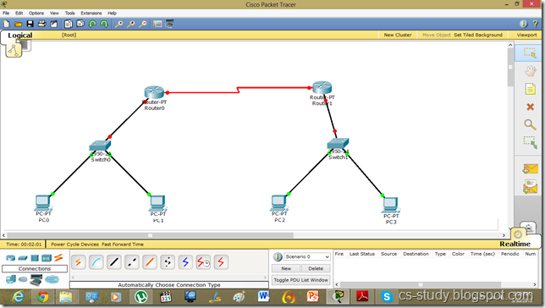](http://lh3.ggpht.com/-lhbZ2ilkpb8/UVgTSFfW5oI/AAAAAAAADF8/LWVAgdohAuU/s1600-h/1%25255B9%25255D.png)

[](http://lh3.ggpht.com/-lhbZ2ilkpb8/UVgTSFfW5oI/AAAAAAAADF8/LWVAgdohAuU/s1600-h/1%25255B9%25255D.png)

**Task 2:** Apply the OSPF on it. But before that, as usual, let us assign IP addresses and change the state of interfaces.

[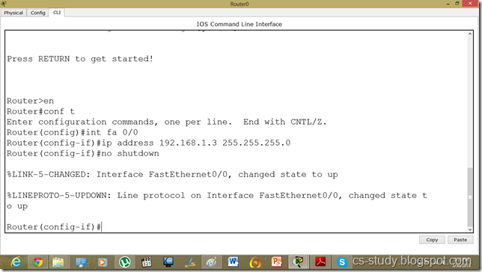](http://lh5.ggpht.com/-EJcTbCdYOAI/UVgTZCWEdVI/AAAAAAAADGM/Gz7-yCPLbV0/s1600-h/2%25255B4%25255D.png)

[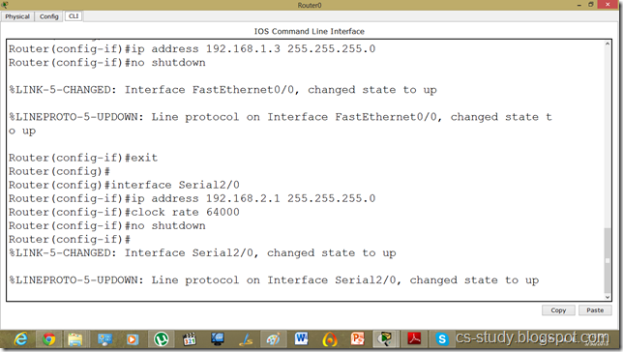](http://lh3.ggpht.com/-jyeiT3G_UrY/UVgTif8153I/AAAAAAAADGc/fGhz0bb-Lzg/s1600-h/3%25255B4%25255D.png)  
Similarly for the other router.   
  
  
 [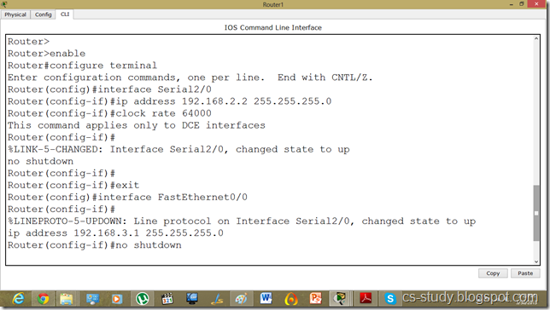](http://lh4.ggpht.com/-rBRnqvYH9Jk/UVgTrm_lIeI/AAAAAAAADGs/4FhOvPo8Uaw/s1600-h/4%25255B4%25255D.png)  
Assigning the IP addresses to PCs as follows.   
  
 [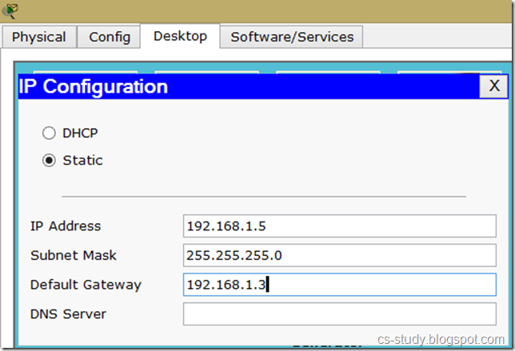](http://lh5.ggpht.com/-03v-zcOv_gs/UVgTzXM38YI/AAAAAAAADG8/wsVGJv2krXc/s1600-h/5%25255B4%25255D.png)

[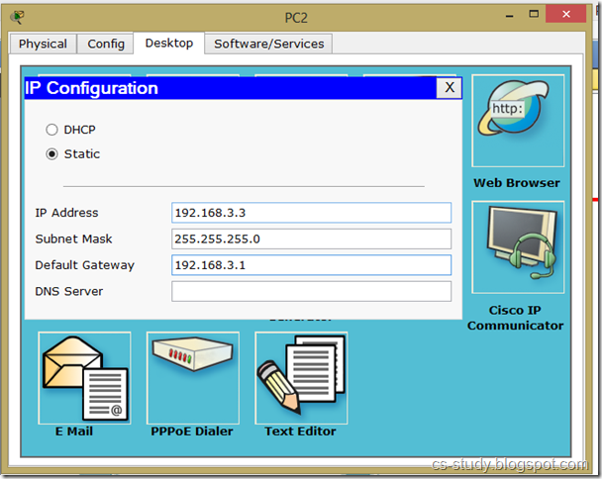](http://lh5.ggpht.com/-Z_oYiKqC-5c/UVgT7rdaopI/AAAAAAAADHM/iKfxA-o8AjQ/s1600-h/6%25255B4%25255D.png)  
  
Now, as we can see, interfaces are up but the communication is not enabled because we have not applied the protocol yet.   
  
 [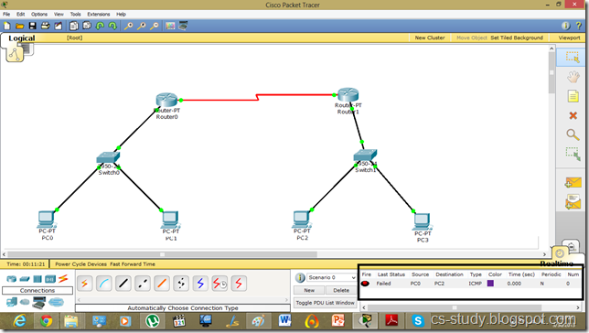](http://lh6.ggpht.com/-0K6cdoBdJ9k/UVgUEAWRSyI/AAAAAAAADHc/gwkMDssWOnA/s1600-h/7%25255B4%25255D.png)  
  
  
 [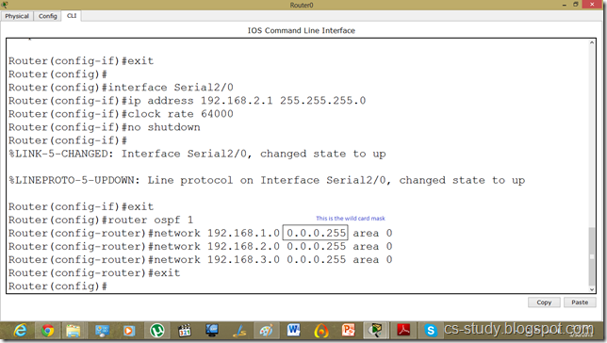](http://lh6.ggpht.com/-XlmD4r0CCBQ/UVgUQ-nSJ9I/AAAAAAAADHs/ohC1HLFVgFs/s1600-h/8%25255B4%25255D.png)  
On router 1.   
  
 [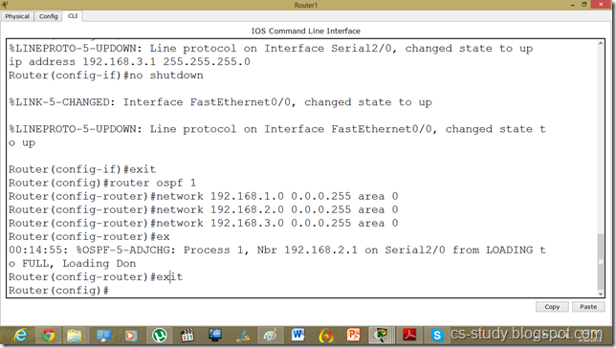](http://lh4.ggpht.com/-oDEh-pwvnRg/UVgUbI43OSI/AAAAAAAADH8/Pei2PLQZDZg/s1600-h/9%25255B4%25255D.png)

After applying protocol successfully , the traffic is flowing . Couple of things worth discussing  
Provide area id and process id on OSPF protocol.   
 Provide wildcard mask on OSPF.   
 [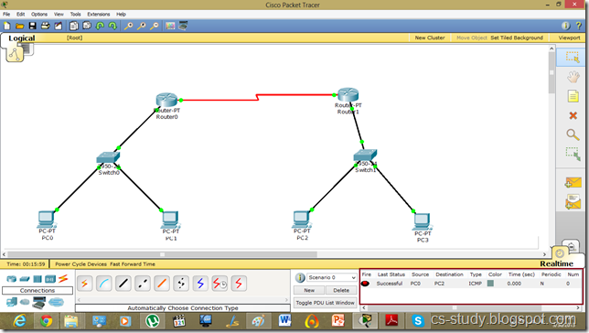](http://lh4.ggpht.com/-aFyVZkvRuok/UVgUnJTbfaI/AAAAAAAADIM/KWlRiqA1ICM/s1600-h/10%25255B4%25255D.png)